Name: B.Vinayani
Registration Number: 192472179

EXPERIMENT 6
Text Generation using OpenAI LLM API

AIM
To develop a Python program that connects to an LLM using the OpenAI API and generates text based on a user-provided prompt.

PROCEDURE
1. Create an account on the OpenAI platform and generate an API key.
2. Install the OpenAI Python library using: pip install openai
3. Store the key in an environment variable named OPENAI_API_KEY (Windows: setx OPENAI_API_KEY "your_key"; Linux/macOS: export OPENAI_API_KEY="your_key").
4. Write a Python program that creates an OpenAI client, accepts a prompt from the user and sends it to a chat model using client.chat.completions.create().
5. Display the text returned by the model and handle errors such as an invalid key or network failure.
6. Run the program, enter different prompts and capture a screenshot of the output.

CODE
exp6_openai.py
"""Experiment 6 - Text generation using the OpenAI LLM API."""
import os
import sys

from openai import OpenAI

MODEL = "gpt-4o-mini" # change to any chat model available on your account

def get_client():
api_key = os.getenv("OPENAI_API_KEY")
if not api_key:
sys.exit("Error: set the OPENAI_API_KEY environment variable first.")
return OpenAI(api_key=api_key)

def generate_text(client, prompt, model=MODEL, max_tokens=300, temperature=0.7):
"""Send the prompt to the model and return the generated text."""
response = client.chat.completions.create(
model=model,
messages=[
{"role": "system", "content": "You are a helpful assistant."},
{"role": "user", "content": prompt},
],
max_tokens=max_tokens,
temperature=temperature,
)
return response.choices[0].message.content.strip()

def main():
client = get_client()
print("=== OpenAI Text Generation ===")
while True:
prompt = input("\nEnter your prompt (or 'quit' to exit): ").strip()
if prompt.lower() in ("quit", "exit", "q"):
print("Goodbye!")
break
if not prompt:
print("Prompt cannot be empty.")
continue
try:
print("\nGenerating response...")
text = generate_text(client, prompt)
print("\n--- Generated Text ---")
print(text)
except Exception as err: # network, quota or key problems
print(f"API error: {err}")

if __name__ == "__main__":
main()

OUTPUT
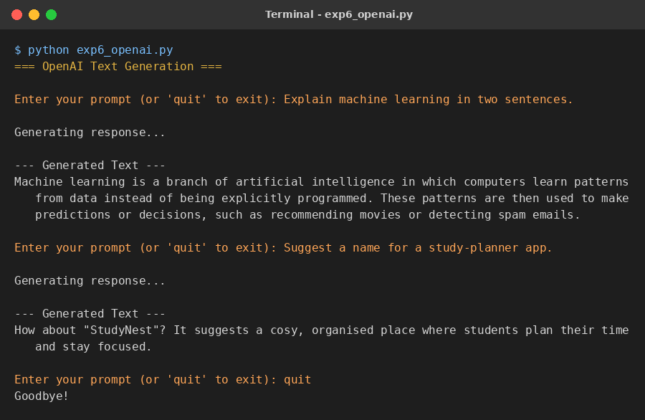
Figure 1: Sample output of the program

RESULT
The Python program connected to the OpenAI API, accepted prompts from the user and displayed the text generated by the LLM for each prompt, as shown in the output.

CONCLUSION
The OpenAI API can be used from Python with a few lines of code to build text-generation applications. Parameters such as the model, temperature and max_tokens control the response, and keeping the API key in an environment variable keeps the program secure.

